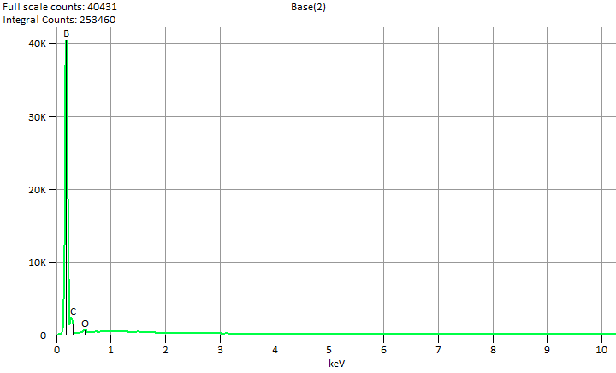

Live Time: 30.0 sec.

Fri Nov 22 16:16:02 2024

Filter Fit Chi Squared:579.113

Errors: +/- 1 Sigma

Correction Method: Proza (Phi-Rho-Z)

Acc.Voltage: 7.0 kV Take Off Angle: 47.9 deg.

Detector: UltraDry

WDS Results Unavailable for: Base(2)

|  |
| --- |
|  |

Quantitative Results for: Base(2)

|  |  |  |  |  |  |  |
| --- | --- | --- | --- | --- | --- | --- |
| ***Element***  ***Line*** | ***Int.***  ***Cps/nA*** | ***Int.***  ***Error*** | ***Weight %*** | ***Weight %***  ***Error*** | ***Atom %*** | ***Atom %***  ***Error*** |
| ***B K*** | 6237.2 | ± 55.00 | 76.2 | ± 0.7 | 78.5 | ± 0.7 |
| ***C K*** | 550.83 | ± 8.54 | 21.5 | ± 0.3 | 19.9 | ± 0.3 |
| ***O K*** | 68.42 | ± 4.67 | 2.3 | ± 0.2 | 1.6 | ± 0.1 |
| ***Total*** |  |  | 100.0 |  | 100.0 |  |

ROI Results for: Base(2)

|  |  |  |
| --- | --- | --- |
| ***Operation*** | ***Gross Counts*** | ***Net Counts*** |

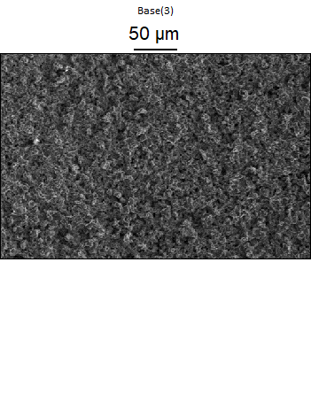

Data Type: Counts

Image Resolution: 512 by 340

Image Pixel Size: 0.69 µm

Map Resolution: 128 by 84

Map Pixel Size: 2.77 µm

Acc. Voltage: 7.0 kV

Magnification: 600

